ANSIBLE TASK -02

Watch ansible-02 video and write down notes.

Install httpd using ansible playbook, use handlers,notifiers.
# create a directory to write the play books -- > mkdir -p /ansible/playbooks
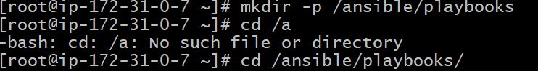
#command to create ansible palybook file -- > vi <file_name>.yaml/yml
THE EXTENSION SHOULD BE .yml (or) .yaml THE FILENAME CAN BE ANYTHING EXTENSION OF FILE IS MUST.
# content in the file
---
- hosts: all
become: yes

tasks:
- name: Install httpd
yum:
name: httpd
state: latest
notify: Restart httpd

handlers:
- name: Restart httpd
service:
name: httpd
state: restarted
#check the syntax -- > ansible-playbook <filename>.yml --syntax-check

#run the playbook -- > ansible-playbooks httpd.yml
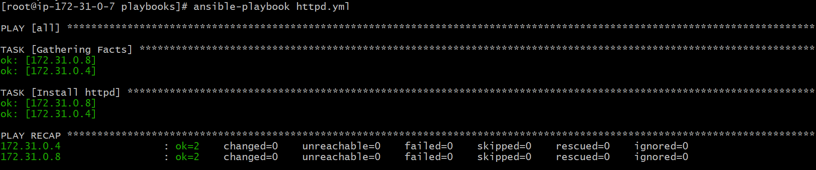
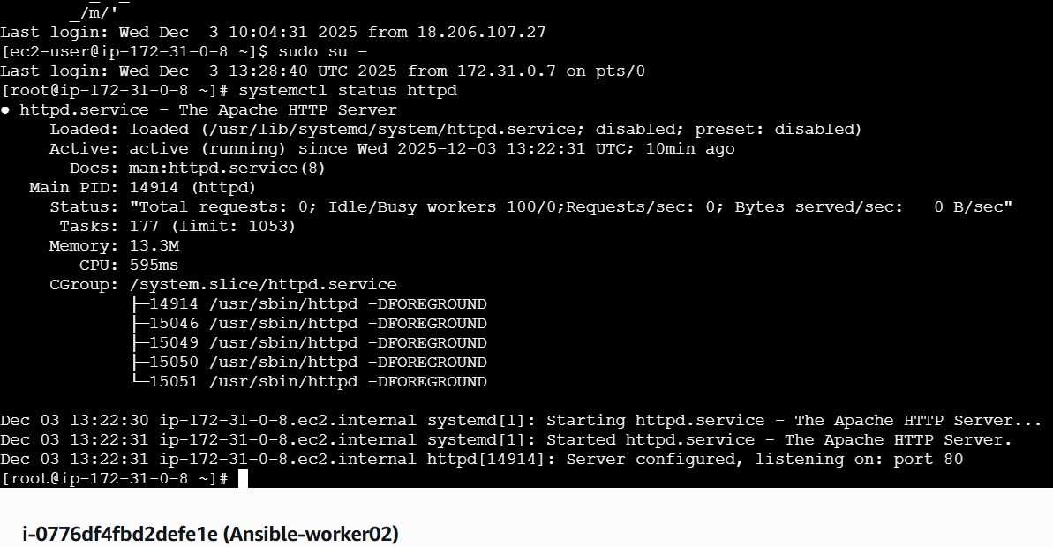
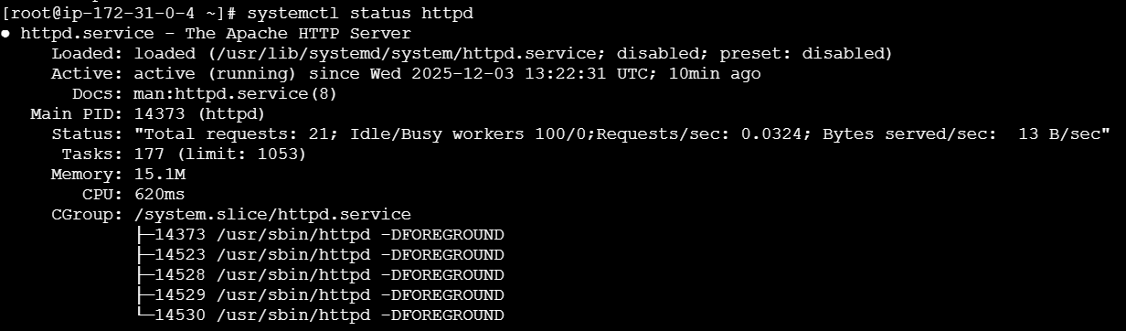

Write a ansible playbook to install apache tomcat.
---
- hosts: all
become: yes

tasks:
- name: Install Java
yum:
name: java-17-openjdk
state: present

- name: Download Tomcat
get_url:
url: https://dlcdn.apache.org/tomcat/tomcat-11/v11.0.14/bin/apache-tomcat-11.0.14.tar.gz
dest: /opt/apache-tomcat-11.0.14.tar.gz

- name: Extract Tomcat
unarchive:
src: /opt/apache-tomcat-11.0.14.tar.gz
dest: /opt
remote_src: yes

- name: Start Tomcat
shell: /opt/apache-tomcat-11.0.14/bin/startup.sh
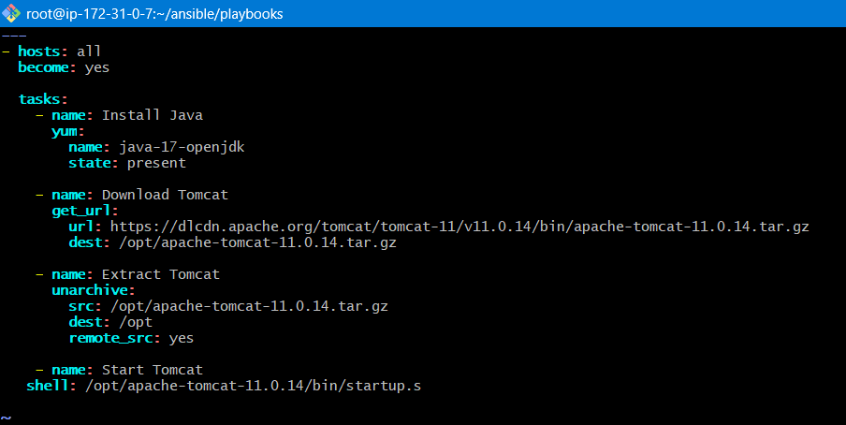

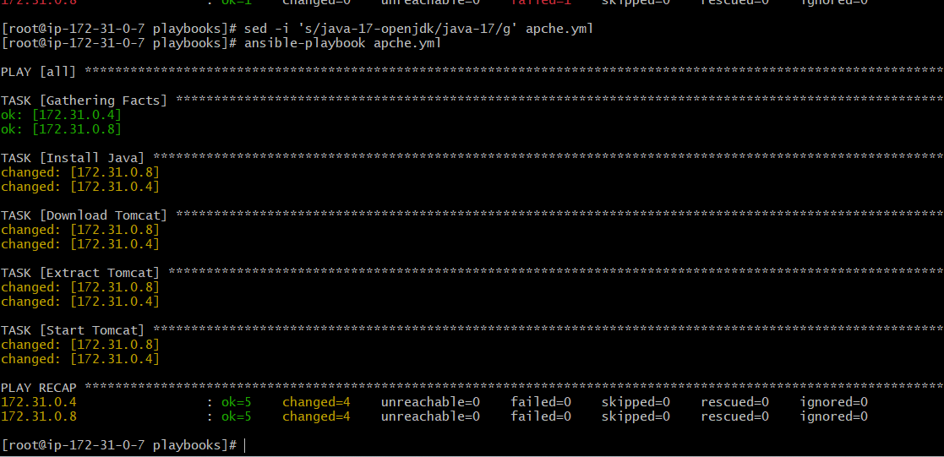

Worker01

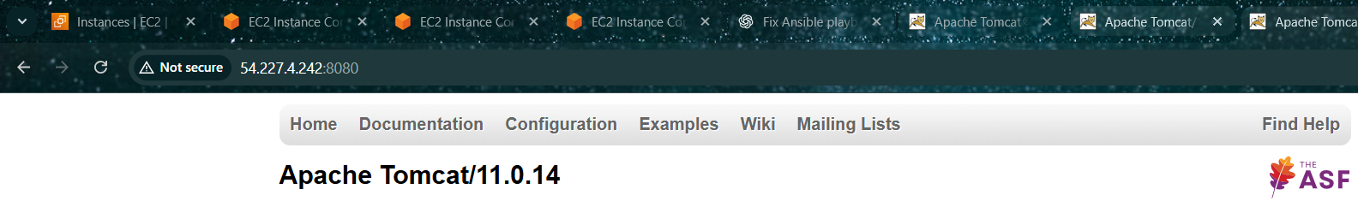
Worker02
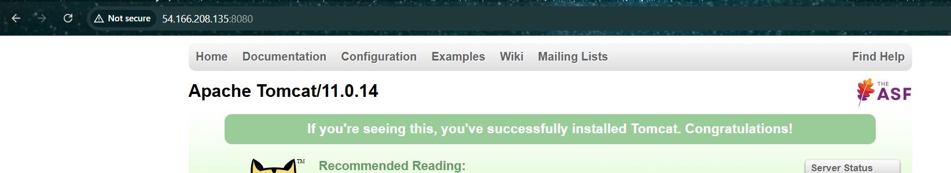

Write a ansible playbook to provision one ec2 on aws.
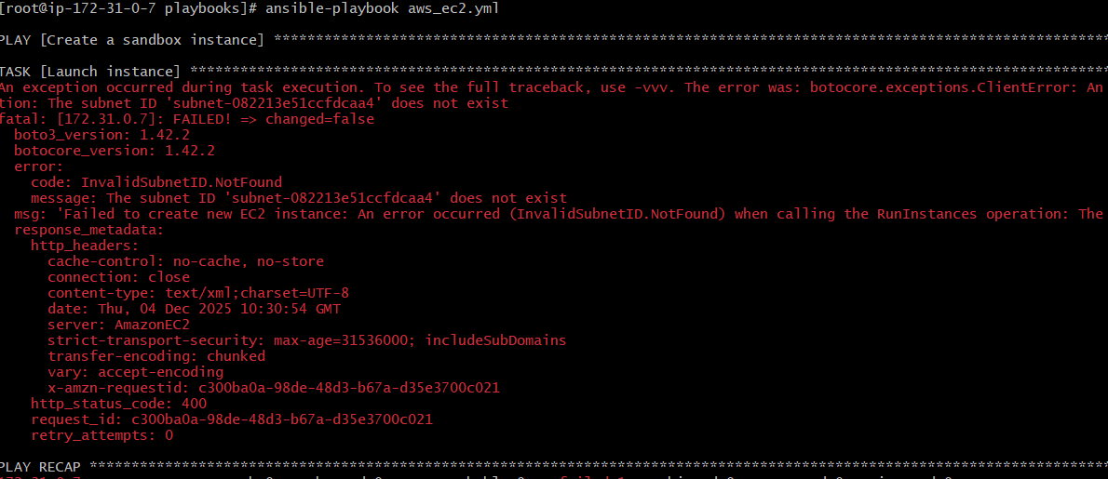
This error is now 100% clear 👍
You are almost done.

✅ What the error REALLY means
FAILED! => Failed to import the required Python library (botocore and boto3)
on ip-172-31-0-7.ec2.internal's Python /usr/bin/python3.9
✅ Key points:
172.31.0.7 is your Ansible control node
You are running AWS modules correctly on localhost
❌ BUT boto3 and botocore are NOT installed on this machine’s Python
This is NOT an Ansible syntax issue anymore.

✅ FIX (VERY SIMPLE – 2 COMMANDS)
🔹 Step 1: Install boto libraries on the control node
Run this on ip-172-31-0-7:
#pip3 install boto boto3 botocore
If pip3 is missing:
#yum install -y python3-pip
#pip3 install boto boto3 botocore

🔹 Step 2: Verify boto3 works
python3 -c "import boto3; print('boto3 OK')"
✅ If you see boto3 OK, you’re good.

✅ OPTIONAL (but recommended): Pin Python interpreter
Add this to your playbook (safe & explicit):
vars:
ansible_python_interpreter: /usr/bin/python3

---
- name: Create a sandbox instance
hosts: localhost
connection: local
gather_facts: no

vars:
ansible_python_interpreter: /usr/bin/python3
instance_type: t2.micro
image: ami-09e5afc68eed60ef4
region: eu-west-2
subnet: subnet-082213e51ccfdcaa4

tasks:
- name: Launch instance
amazon.aws.ec2_instance:
name: simple-ec2
instance_type: "{{ instance_type }}"
image_id: "{{ image }}"
wait: yes
region: "{{ region }}"
vpc_subnet_id: "{{ subnet }}"
network:
assign_public_ip: true

✅ Run Again
ansible-playbook aws_ec2.yml
✅ This time it WILL work and create the EC2 instance.

✅ Remember This Rule (EXAM + REAL WORLD)
✅ AWS modules run on control node only
✅ boto3 is required on control node
✅ Error mentions Python → install Python libs, not Ansible modules

If you want next:
✅ Terminate EC2 with Ansible
✅ Create key pair + security group
✅ Provision EC2 + Apache in one go
✅ Ultra-short exam version
Just tell me 👍

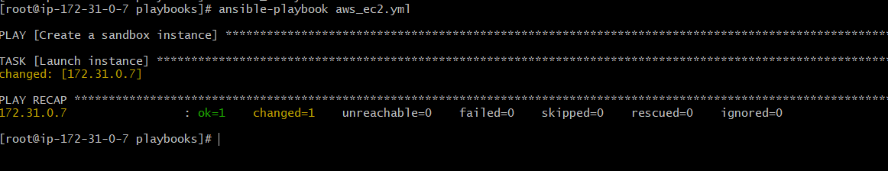
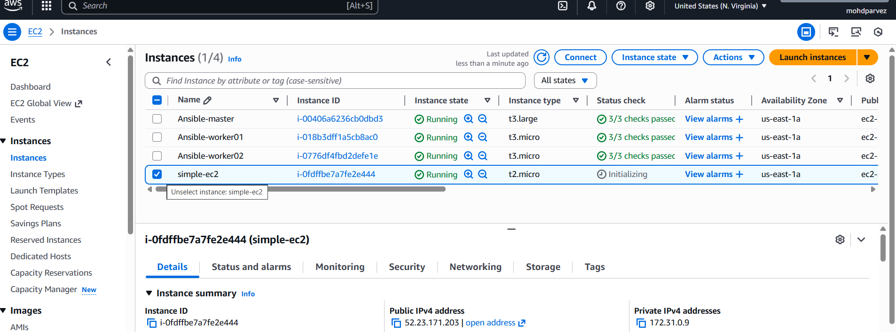

Write a ansible playbook to copy one file from node-1 to node-2.
I have tst.txt file in the worker02/node02
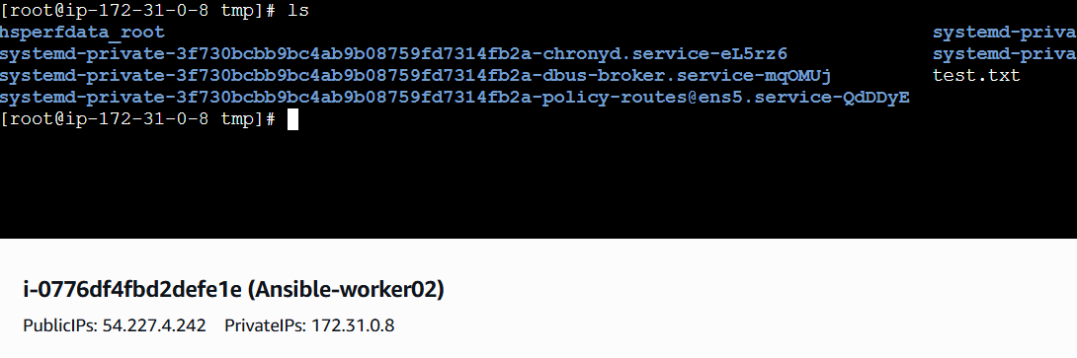

Create play book to copy file from one node to another
# vi copy.yml
---
- name: Fetch file from worker02
hosts: worker02
become: yes

tasks:
- name: Fetch /tmp/test.txt from worker02
fetch:
src: /tmp/test.txt
dest: /tmp/test.txt
flat: yes

- name: Copy file to worker01
hosts: worker01
become: yes

tasks:
- name: Copy /tmp/test.txt to worker01
copy:
src: /tmp/test.txt
dest: /tmp/test.txt
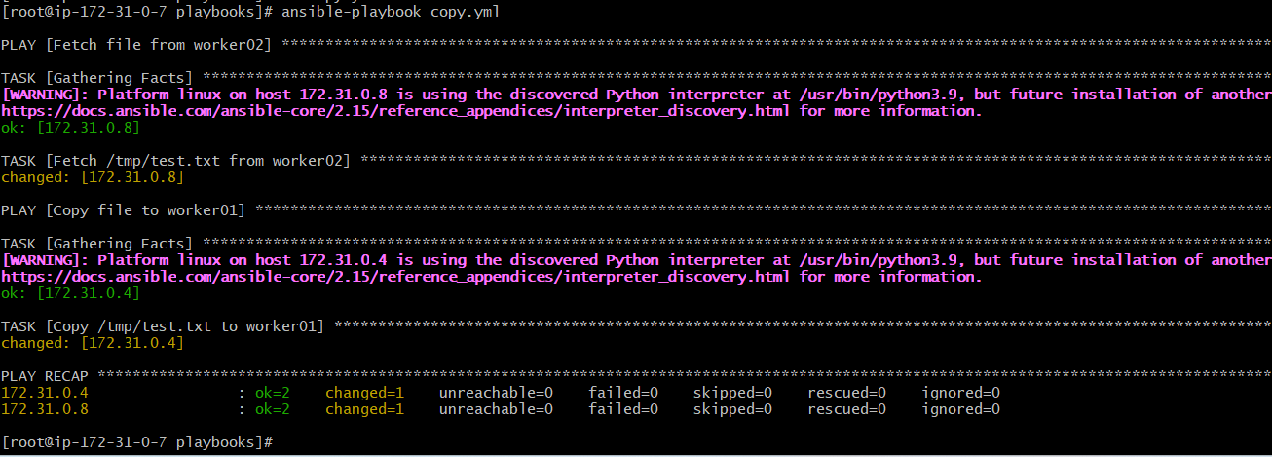

Write a ansible playbook to create different files with different names using single playbook.
---
- name: Create multiple files
hosts: all
become: yes

tasks:
- name: Create different files
file:
path: "/tmp/{{ item }}"
state: touch
loop:
- file1.txt
- file2.log
- file3.conf
- file4.data
